Name: Shubham Shashwat Roll no. 244CA053 LAB-4

1. Retrieve the names of all instructors who teach at least one course in the 'Computer
Science' department.
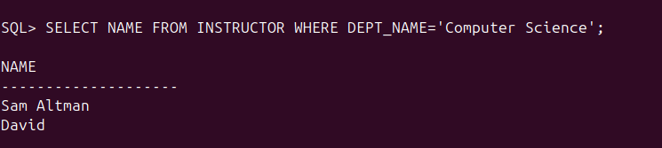
2. List all students who have taken at least one course in 'Fall' and 'Spring' semesters in
the same year.
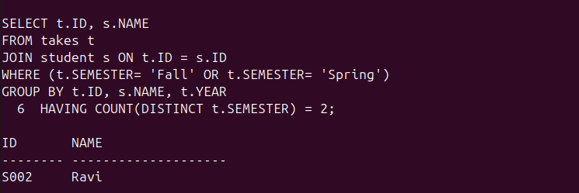

3. Find all classrooms that have a capacity of more than 100 but are not assigned to any
section.
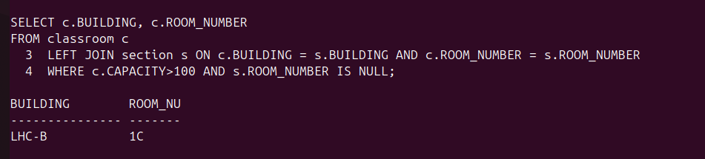
4. Display all courses along with their prerequisites, including courses that have no
prerequisites.

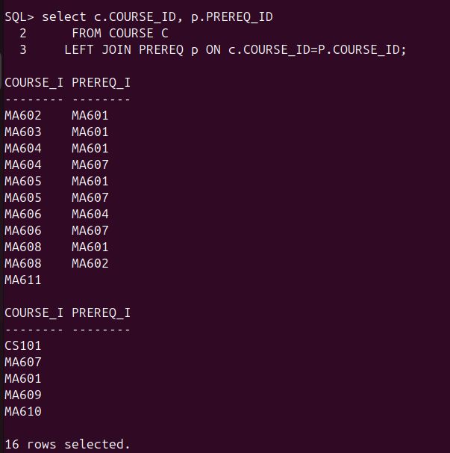
5. Retrieve the list of instructors who have never taught a course.

6. Find the total budget allocated to all departments that have at least one instructor
earning more than ₹100,000.
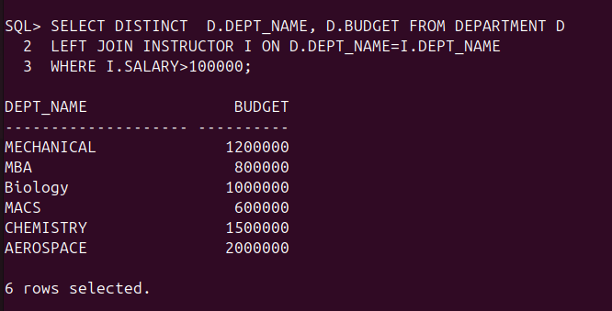
7. Find the average salary of instructors grouped by department but only include
departments with more than 5 instructors.

8. Find the total number of students enrolled in each course for every semester, and sort by
semester and number of students (descending).
9. Determine which department has the highest average course credit.
10. Find the top 3 courses with the most students enrolled across all semesters.
11. Find all students who have taken every course taught by the instructor 'John Doe'.
12. Retrieve the names of students who have the same name as their advisor.
13. Find all instructors who have taught at least one course that they did not belong to the
department of.
14. List all students who have taken a course in a classroom that has a capacity less than
the number of students enrolled.
15. Find students who have taken every course offered by their department.
16. Identify the department(s) with the largest number of distinct courses offered.
17. Find students who have taken a course but have not received a grade.
18. Retrieve the details of instructors who have the exact same salary as another instructor.
19. Identify all courses that have prerequisites, but the prerequisite itself has no prerequisite.
20. Find all students who have taken courses in every semester (Fall, Winter, Spring,
Summer) at least once.
21. Find all prerequisite chains for a given course (i.e., if A is a prerequisite for B, and B is a
prerequisite for C, return A → B → C).
22. List all courses that have at least two levels of prerequisites (i.e., a prerequisite has
another prerequisite).
23. Find the shortest prerequisite chain for any course that eventually leads to a specific
course, say 'CS101'.
24. Identify students who have taken a course whose prerequisite they have never taken.
25. Find all instructors who have taught a course that has another course as a prerequisite.
26. Find all students who have the same total credits as another student in a different
department.
27. Identify instructors who have the highest salary in their department but still earn less
than the highest salary in another department.
28. Retrieve students who have taken more than one course but have failed at least half of
them (assuming grade 'F' is failing).
29. List all departments where the highest-paid instructor earns more than the total
department budget divided by the number of instructors.
30. Find courses that have never been taught in the same semester for consecutive years.
31. Rank instructors by salary within their department and return only the second-highest
salary in each department.
32. Find students who have taken the most credits in a single semester.
33. Retrieve the top 5 students with the highest total credits, including ties.
34. Determine which instructors have taught the most unique courses.
35. Find students who have received the highest grade (alphabetically) in the most number
of distinct courses.
36. Find all students who have taken courses in the 'Computer Science' and 'Mathematics'
departments but not in 'Physics'.
37. List students who have taken every course in their department except for one course.
38. Find all instructors who have taught at least one course in every semester.
39. Retrieve students who have the same advisor but are from different departments.
40. Find courses that are prerequisites for some courses but are also taken by students who
have never taken the main course.
41. Increase the salary of instructors who have taught more than 5 courses by 10%.
42. Remove students who have never taken any courses and have no advisor assigned.
43. Assign an advisor to every student who does not have one, choosing the instructor from
the same department with the highest salary.
44. Update the grade of students who initially received 'F' but later retook the same course
and scored higher.
45. Delete all courses that have not been offered in the last 10 years.
46. Find the instructor who has taught a course in the largest number of unique classrooms.
47. Determine the department with the most students who have taken at least one course
but have zero total credits recorded.
48. Identify courses where the number of students who failed is greater than those who
passed.
49. Find the classroom that has hosted the highest number of distinct courses across all
semesters.
50. Retrieve students who have been enrolled in at least one course every year for at least 4
consecutive years.

